**Fading Channels &Mobile Communications**

**IIT Kharagpur**

**Date: 8/Oct/2018**

**Exp 5A: SINR(Downlink)**

**Name: MOHIT KAPOOR**

**__________________________________________________________**

**SINR vs Distance**

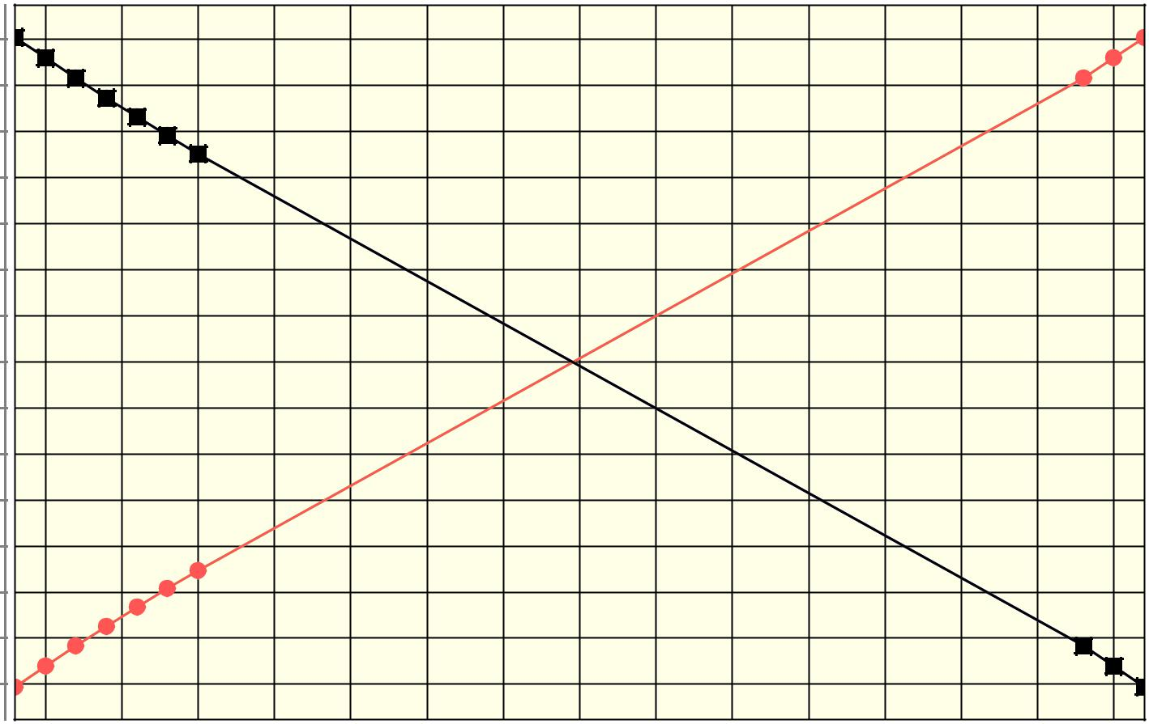

|  |  |  |  |  |  |  |  |  |  |  |  |  |  |  |  |  |
| --- | --- | --- | --- | --- | --- | --- | --- | --- | --- | --- | --- | --- | --- | --- | --- | --- |
|  | 17 | .5 |  |  |  |  |  |  |  |  |  |  |  |  |  |  |
|  | 15 | .0 |  |  |  |  |  |  |  |  |  |  |  |  |  |  |
|  | 12 | .5 |  |  |  |  |  |  |  |  |  |  |  |  |  |  |
|  | 10 | .0 |  |  |  |  |  |  |  |  |  |  |  |  |  |  |
|  | 7 | . 5 |  |  |  |  |  |  |  |  |  |  |  |  |  |  |
| **)** | 5 . 0 | |  |  |  |  |  |  |  |  |  |  |  |  |  |  |
| **B** | 2 | . 5 |  |  |  |  |  |  |  |  |  |  |  |  |  |  |
| **( d** |  |  |  |  |  |  |  |  |  |  |  |  |  |  |
| 0 | . 0 |  |  |  |  |  |  |  |  |  |  |  |  |  |  |
| **I N R** |  |  |  |  |  |  |  |  |  |  |  |  |  |  |
| -2.5 | |  |  |  |  |  |  |  |  |  |  |  |  |  |  |
| **S** | -5.0 | |  |  |  |  |  |  |  |  |  |  |  |  |  |  |
|  |  |  |  |  |  |  |  |  |  |  |  |  |  |  |
|  | -7.5 | |  |  |  |  |  |  |  |  |  |  |  |  |  |  |
|  | -10.0 | |  |  |  |  |  |  |  |  |  |  |  |  |  |  |
|  | -12.5 | |  |  |  |  |  |  |  |  |  |  |  |  |  |  |
|  | -15.0 | |  |  |  |  |  |  |  |  |  |  |  |  |  |  |
|  | -17.5 | |  |  |  |  |  |  |  |  |  |  |  |  |  |  |
|  |  | 200 | 225 | 250 | 275 | 300 | 325 | 350 | 375 | 400 | 425 | 450 | 475 | 500 | 525 | 550 |
|  |  |  |  |  |  |  |  | **D i s t a n c e ( m )** | | |  |  |  |  |  |  |



SINR1 SINR2 SINR1(EnteredValue) SINR2(EnteredValue)



**Discussion:-**

**Enter your discussion**

(Signature of MOHIT KAPOOR)

(Signature of Faculty)

**REPORT**

|  |  |  |  |  |  |  |  |  |
| --- | --- | --- | --- | --- | --- | --- | --- | --- |
|  | **Pr1(dBm)** | **d1(m)** | **Pr2(dBm)** | **d2(m)** | **SINR1(dB)** | **SINR2(dB)** | **Entered** | **Entered** |
|  |  |  |  |  |  |  | **SINR1(dB)** | **SINR2(dB)** |
|  | -59.98 | 190.0 | -77.63 | 560.0 | 17.62 | -17.65 | 17.62 | -17.65 |
|  |  |  |  |  |  |  |  |  |
|  | -60.82 | 200.0 | -77.34 | 550.0 | 16.5 | -16.52 | 16.5 | -16.52 |
|  |  |  |  |  |  |  |  |  |
|  | -61.62 | 210.0 | -77.04 | 540.0 | 15.4 | -15.42 | 15.4 | -15.42 |
|  |  |  |  |  |  |  |  |  |
|  | -62.38 | 220.0 | -76.73 | 530.0 | 14.33 | -14.35 | 14.33 | -14.35 |
|  |  |  |  |  |  |  |  |  |
|  | -63.1 | 230.0 | -76.42 | 520.0 | 13.3 | -13.32 | 13.3 | -13.32 |
|  |  |  |  |  |  |  |  |  |
|  | -63.8 | 240.0 | -76.1 | 510.0 | 12.28 | -12.3 | 12.28 | -12.3 |
|  |  |  |  |  |  |  |  |  |
|  | -64.46 | 250.0 | -75.78 | 500.0 | 11.3 | -11.32 | 11.3 | -11.32 |
|  |  |  |  |  |  |  |  |  |
|  | -77.04 | 540.0 | -61.62 | 210.0 | -15.42 | 15.4 | -15.42 | 15.4 |
|  |  |  |  |  |  |  |  |  |
|  | -77.34 | 550.0 | -60.82 | 200.0 | -16.52 | 16.5 | -16.52 | 16.5 |
|  |  |  |  |  |  |  |  |  |
|  | -77.63 | 560.0 | -59.98 | 190.0 | -17.65 | 17.62 | -17.65 | 17.62 |
|  |  |  |  |  |  |  |  |  |

(Signature of MOHIT KAPOOR)

(Signature of Faculty)